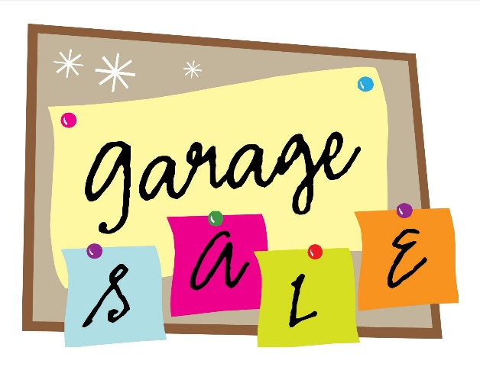
Hidden Hills Neighborhood Garage Sale

Saturday, October 13th 2018
7:00 a.m. – noon

Registration Form
Cost $10 per Household
(New resident? Look for a coupon in your Welcome Basket)
Questions? Contact
Heather Hines @heather.hines@rcsd.ms or 601-394-7305

******************************************
Registration starts NOW!
Please register in advance in case we need to
purchase additional signs
(Garage Sale signs will be distributed when you submit your form.)

Name: _________________________________________________________________
Home Address:__________________________________________________________
Phone Number:__________________________________________________________
Email Address:__________________________________________________________
(Please fill out completely and PRINT)
If paying by check, please make your check payable to Hidden Hills HOA. Order forms and payment can be turned in to Mary at the clubhouse or to Heather @ 538 Springhill Crossing.
Club House Hours: Monday – Thursday, 9:00 – 1:00

Register NOW!

