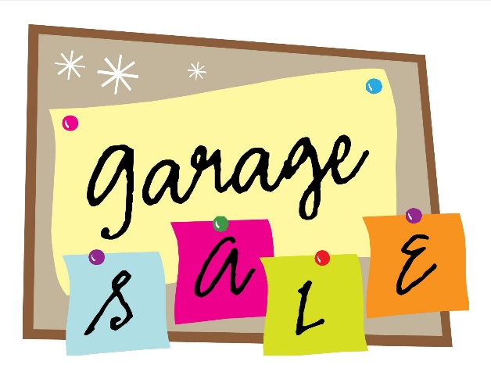
Hidden Hills Neighborhood Garage Sale

Saturday, October 7,2017
7:00 a.m. – noon

Registration Form
Cost $10 per Household
(New resident? Look for a coupon in your Welcome Packet)

Questions? Contact Michelle Untch @ michelleuntch@hotmail.com
******************************************

Registration starts NOW!
Please register in advance in case we need to purchase more signs
(Garage Sale signs will be distributed the week of the sale)

Name: _____________________________________
Home Address:______________________________
Phone Number:______________________________
Email Address:________________________________________
(Fill out completely and PRINT neatly)

If paying by check, make your check payable to Hidden Hills HOA. Put your check (or cash) with this form in the drop box at the Clubhouse.

Register NOW!

